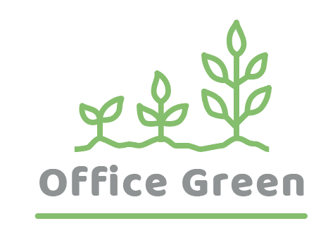

Project Plant Pals

Operations & Training Plan

**February 05th**

Document Status: **Draft** | In Review | Approved

**Executive Summary:**

|  |
| --- |
| **Project Goal** |
| ***SMART: S****pecific,* ***M****easurable,* ***A****ttainable,* ***R****elevant, and* ***T****ime-bound*   * Increase revenue for Office Green by 5%: * Specific (increase revenue by 5%), * Measurable (able to track the increase in revenue), * Attainable (with efficient operations and high-quality customer experience), * Relevant (to the success of the Plant Pals project and Office Green), * Time-bound (within the six-month implementation period). |

|  |
| --- |
| **Deliverables** |
| 1. Deliver 95% of orders on time within one month of launch: 2. Specific (95% of orders delivered on time), 3. Measurable (able to track order delivery times), 4. Attainable (with a well-planned delivery and logistics plan), 5. Relevant (to the success of the Plant Pals service), 6. Time-bound (within one month of launch). |

|  |
| --- |
| **Business Case / Background** |
| **Why are we doing this?**   * The Plant Pals project is being undertaken to create sustainable fulfillment and delivery practices for the service's day-to-day operations. The main goal is to ensure an efficient, high-quality customer experience, which will help mitigate potential revenue losses due to late shipments and cancellations. By putting internal processes and training procedures in place, the project aims to support the larger goal of increasing revenue for Office Green by 5%. This will be achieved through the implementation of an Operations and Training plan within a budget of $75,000 and a time frame of six months. |

|  |
| --- |
| **Benefits, Costs, and Budget** |
| **Benefits:**   * Support new service leading to 5% revenue increase, reduce late shipments and related costs, increase customer satisfaction * *Additional benefits (optional)*:   **Costs:**   * Price of software, installation fees, time spent on hiring and training * *Additional cost areas (optional)*:   **Budget needed:**   * $75,000 |

|  |
| --- |
| **Scope and Exclusion** |
| **In-Scope:**   * Customer service standards, delivery processes, training protocols * *Other in-scope items (optional)*:   **Out-of-Scope:**   * Product development, vendor contracts * *Other out-of-scope items (optional)*: |

|  |
| --- |
| **Project Team** |
| **Project Sponsor:** Director of Operations  **Project Lead:** Project Manager (You!)  **Project Team:** Fulfillment Director, Quality Assurance Tester, Inventory Manager, Financial Analyst, Human Resources Specialist, Training Manager  **Additional Stakeholders:** VP of Customer Success, Account Manager, Receptionist, Sales Director, Sales Team, Marketing Director, Investors |

|  |
| --- |
| **Measuring Success** |
| **What is acceptable:**  The success of the Plant Pals project can be measured by the following metrics:   1. On-time delivery rate: The percentage of orders that are delivered within the target timeframe of one month after the service launch. A target of 95% on-time delivery is set. 2. Order processing efficiency: The time it takes for orders to be packaged and ready for shipment, with a target of two business days. 3. Employee training completion rate: The percentage of employees who have completed the training program before the official service launch. A target of 90% completion is set. 4. Revenue increase: The increase in revenue for Office Green as a result of the project. A target of 5% increase is set.   If the project meets or exceeds these metrics, it can be considered a success. However, it's important to note that success can also be measured by other factors, such as customer satisfaction, the effectiveness of the operational processes and tools put in place, and the overall smoothness of the Plant Pals service. |